Operating Instructions
HazLoc LED Lighting
Model L1512
Drawing No: Instruction_L1512_IECEx
Revision Level: 01 Date: 2018-09-12

Top Hi-Tech Co., Ltd.
9F, No. 1, Zhongshan Rd
Tucheng District
New Taipei, 236 Taiwan

Website: www.tht-ex.com
TEL: +886 2 22671234
FAX: +886 2 22691166
e-mail: sales@tht-ex.com

Subject to alterations.

Contents
- General Safety Instructions ………………………………………………………………..…………….……..1
- Intended Field of Application………………………………………………………………..…………….……1
- Technical Data ……………………………………………………………….……….……………..……….....2
- Dimension ……………………………………………………………………………………….………….......3
- Assembly and Installation ……………………………………………………………………….......................4
- Maintenance …………………………………………………………………………………………………….5
- Accessories and Spare Parts …………………………………………………………………………………....5
- Transport, Storage and Disposal ……………………………………………………….……………………….5
- General Safety Instructions
WARNING
This manual contains basic safety instructions to be observed during installation, operation and maintenance of the apparatus, and for properly and safety run of the apparatus according to its performance data. Any damage of the apparatus may result explosion protection null and void. This manual represents the most relevant information about the product, applicable codes and regulations shall supplement it. Non-observance will endanger persons, plant and the environment. The person in charge is required to secure its employment in the industrial unit. Any improper usage, as well as non-compliance with the rules under this manual, shall release the manufacturer’s all responsibilities.
WARNING - Potential Electrostatic Charging Hazard.
WARNING - The luminaire shall not be opened.
WARNING - The luminaire does not have a test port fitted.

  - Before assembly/commissioning:
- Read through the operating instructions.
- Give adequate training to the assembly and operating personnel.
- Ensure that the contents of the operating instructions are fully understood by the personnel in charge.
- The national installation and assembly regulations (e.g. IEC/EN 60079-14) apply.
  - When operating the device:
- Ensure the operating instructions are made available for the person in charge on location at all times.
- Observe these instructions, other working instructions and national safety regulations.
- Verify the implementation of safety instructions.

- Intended Field of Application
The HazLoc LED Lighting, Model L1512 is intended for using in gas explosive atmospheres ( Zone 2 according to IEC60079-10-1) and dust explosion hazards (Zone 21 according to IEC60079-10-2). The use in other potentially explosive atmospheres does not correspond to the designated use and is therefore not allowed. The apparatus is designed for using in indoor and outdoor environments.
- Technical Data
Item | Description
Explosion Protection  IECEx  Gas Explosion Protection  Dust Explosion Protection  ATEX  Gas Explosion Protection  Dust Explosion Protection | IECEx UL 18.0031X Issue 0  Ex nR IIC T6 Gc  Ex tb IIIC T85°C Db  DEMKO 18 ATEX 2030X Rev. 0 and DEMKO 18 ATEX 2131X Rev. 0   II 3 G Ex nR IIC T6 Gc  0035 II 2 D Ex tb IIIC T85°C Db
Rating | THTH1512ANA*1N0 – 110 Vac, 50/60 Hz, 140 W  THTH1512ANA*1Q0 – 110 Vac, 50/60 Hz, 160 W  THTH1512ANA*1S0 – 110 Vac, 50/60 Hz, 180 W  THTH1512ANA*1U0 – 110 Vac, 50/60 Hz, 200 W  THTH1512ANK*1N0 – 110 Vac, 50/60 Hz, 140 W  THTH1512ANK*1Q0 – 110 Vac, 50/60 Hz, 160 W  THTH1512ANK*1S0 – 110 Vac, 50/60 Hz, 180 W  THTH1512ANK*1U0 – 110 Vac, 50/60 Hz, 200 W  THTH1512ANA*2N0 – 220 Vac, 50/60 Hz, 140 W  THTH1512ANA*2Q0 – 220 Vac, 50/60 Hz, 160 W  THTH1512ANA*2S0 – 220 Vac, 50/60 Hz, 180 W  THTH1512ANA*2U0 – 220 Vac, 50/60 Hz, 200 W  THTH1512ANK*2N0 – 220 Vac, 50/60 Hz, 140 W  THTH1512ANK*2Q0 – 220 Vac, 50/60 Hz, 160 W  THTH1512ANK*2S0 – 220 Vac, 50/60 Hz, 180 W  THTH1512ANK*2U0 – 220 Vac, 50/60 Hz, 200 W  THTH1512ANA*9N0 – 277 Vac, 50/60 Hz, 140 W  THTH1512ANA*9Q0 – 277 Vac, 50/60 Hz, 160 W  THTH1512ANA*9S0 – 277 Vac, 50/60 Hz, 180 W  THTH1512ANA*9U0 – 277 Vac, 50/60 Hz, 200 W  THTH1512ANK*9N0 – 277 Vac, 50/60 Hz, 140 W  THTH1512ANK*9Q0 – 277 Vac, 50/60 Hz, 160 W  THTH1512ANK*9S0 – 277 Vac, 50/60 Hz, 180 W  THTH1512ANK*9U0 – 277 Vac, 50/60 Hz, 200 W
CRI | > 80
Power Factor | cos φ ≧ 0.9
Ambient Temperate Range | -20°C≤Ta ≤+40°C
Degree of Protection | IP67
Material | Enclosure: Aluminum alloy; Lens Cover: PC
LED Service Life | 60,000 hrs
Entrance Hole | NPT 3/4“ threaded hole incorporate with Cable Gland
Cable Gland | NPT 3/4“×1.814 mm, Secure to Top Cover with torque value 561 kgf-cm.
Luminaire provide with cable gland and cable which assembled at the factory.
A torque with 510 Kgf-cm shall apply to the Pressure Nut to compress the Tube at the factory.
Cable gland is for circular (round), non-metal sheathed cables.
The cable type is: SOOW, 18/3C AWG, 1-3 m length.
Size of Tube: Ø9.0 (Fitting Cable: OD: Ø9), L=15 mm

Mounting Type / Weight | Two-position adjustable trunnion (Wall/Ceiling) mounting
Mounting Type / Weight | 13.0 kg
Mounting Type / Weight | Bending electrical tube mounting 25º | Bending electrical tube mounting 90º | Straight electrical tube mounting
Mounting Type / Weight | 13.5 kg | 14.0 kg | 12.5 kg
- Dimensions (All Dimensions in mm)
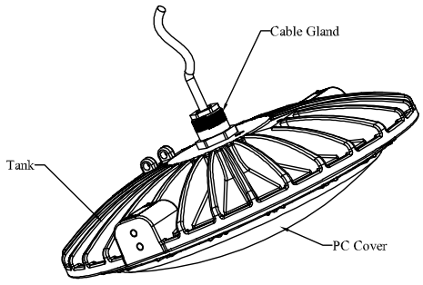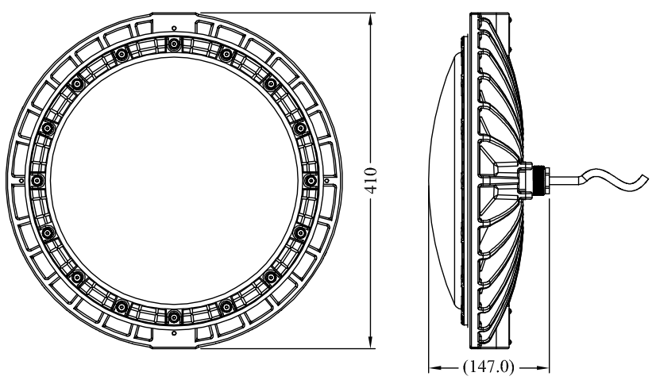
Cable type: SOOW, 18/3C AWG, 1-3 m length

- Assembly and Installation (The luminaire shall not be opened during installation)
  - Mounting Bracket Installation
    - Two Position Adjustable Trunnion (Wall & Ceiling) Mounting

- The mount bracket is for the use of both ceiling mount (Figure 1) and wall mount (Figure 2).
- Position the bracket holders and secured by means of the provided M8 screws, 61.0 kgf-cm.
- Secure the wall/ceiling mounting bracket to the mounting surface by using four fasteners (not provided).
- The angle of luminaire can be adjusted.

Figure 2
Figure 1

    - Straight Electrical Tube Mounting

- The straight electric tube, one end secured to Connector of Cable Gland by integral NPT 3/4” male threads and with a setscrew; the other end
provided with 3/4” NPT male threads for connecting with conduit.
- Thread the tube mounting on conduit and torque until wrench-tight with 2700 kgf-cm.
- Tighten tube locking setscrew to conduit, 1.0 N-m. (Figure 3)
Figure 3

5.1.3 Bending Electrical Tube Mounting
- The bending electrical tube, one end secured to Cable Gland by integral M35 female threads and with a setscrew; the other end provided with 1-1/2” NPT female threads for connecting with conduit.
- Thread the tube mounting on conduit and torque until wrench-tight with 6600 kgf-cm.
- Tighten tube locking setscrew to conduit, 1.0 N-m. (Figures 4 and 5)

Figure 5
Figure 4

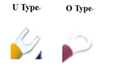
  - Ground wire

- The external earth ground wire installation and terminal type as show the right pictures.
- Ground wire cross-sectional area=4.0mm²，max LED current=1.0A; @V=110Vac-10%.
- Both ground screw and washer material is stainless steel.
- Screw hole spec: M5.
- Torque requirement: 14.5 kgf.cm.
- Ensure wire is tied assured.

  - Putting into Service
Before putting into operating, it’s necessary to ensure that:
- the lighting is correctly installed.
- the connection has been correctly made.
- the cable has been inserted correctly.
- the voltage is correctly

- Maintenance
WARNING
- To avoid dangers due to energized parts, all connections and wiring must be disconnected from the power supply. Secure the connections against unauthorized activation.
- To avoid risk of burn to hands, let the luminaire cool down for approximate 30 minutes before touching them.
- Repairs are only to be carried out by the manufacturer. Unauthorized repair shall cause the manufacturer’s liability and warranty expires.
- Do not hit or scratch the PC Cover painted area
Regular Maintenance
- Consult the relevant national regulations (e.g. IEC/EN 60079-17) to determine the type and extent of inspections.
- Arrange the plan of regular inspection with the equipment, one time per 3-month at least, so that any defects in the equipment which may be anticipated are promptly detected.
To check as part of the maintenance schedule as following:
- Cracks or damages on the PC cover and/or on the enclosure.
- Condition of the connecting cables.
- Screws of the mounting bracket are tightened.
- Accessories and Spare Parts
WARNING
Use only original THT-EX accessories and spare parts. For accessories and spare parts, see data sheet at www.tht-ex.com.

- Transport, Storage and Disposal
- Transport and storage is only allowed in the original packaging, on the way pointed out on the carton box.
- Transport – Shock-free in its original carton, do not drop, and handle carefully.
- Store – Store in a dry place in its original packaging.
- Disposal – Ensure environmentally friendly disposal of all components according to the legal regulations.

