**Operating Instructions**

**Flameproof Battery Backup LED Lighting**

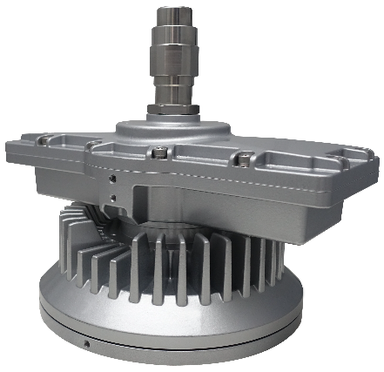**Model L1815A**

Drawing No: RD-EX-L1815A-A

Revision Level: A0 Date: 2020-06-04

Top Hi-Tech Co., Ltd.

9F, No. 1, Zhongshan Rd.,

Tucheng District,

New Taipei City, 236 Taiwan

Website: [www.tht-ex.com](http://www.tht-ex.com)

TEL: +886 2 22671234

FAX: +886 2 22691166

e-mail: sales@tht-ex.com

**Contents**

1. General Safety Instructions ………………………………………………………………..…………….……..1
2. Intended Field of Application………………………………………………………………..……………1
3. Technical Data ……………………………………………………………….……….……………..……….....2
4. Model code……………………………………………………………………………………………………..3
5. Dimension ……………………………………………………………………………………….………….......3
6. Assembly and Installation ………………………………………………………………………................3-5
7. Maintenance …………………………………………………………………………………………………….5
8. Accessories and Spare Parts …………………………………………………………………………………....5
9. Transport, Storage and Disposal ……………………………………………………….………………………5
10. **General Safety Instructions**

** WARNING**

**This manual contains basic safety instructions to be observed during installation, operation and maintenance of the apparatus, and for properly and safety run of the apparatus according to its performance data. Any damage of the apparatus may result explosion protection null and void. This manual represents the most relevant information about the product, applicable codes and regulations shall supplement it. Non-observance will endanger persons, plant and the environment. The person in charge is required to secure its employment in the industrial unit. Any improper usage, as well as non-compliance with the rules under this manual, shall release the manufacturer’s all responsibilities.**

**WARNING – The luminaire shall not be opened.**

**WARNING – The flameproof joints are not intended to be disassembled or repaired.**

**WARNING – Customers should install and charge within one month after receiving the lighting fixtures.**

**WARNING – Potential Electrostatic Charging Hazard.**

**WARNING – Do not clean or rub when an explosive atmosphere may be present.**

* 1. **Before assembly/commissioning:**
* Read through the operating instructions.
* Give adequate training to the assembly and operating personnel.
* Ensure that the contents of the operating instructions are fully understood by the personnel in charge.
* The national installation and assembly regulations (e.g. IEC 60079-14) apply.
  1. **When operating the device:**
* Ensure the operating instructions are made available for the person in charge on location at all times.
* Observe these instructions, other working instructions and national safety regulations.
* Verify the implementation of safety instructions.

1. **Intended Field of Application**

The flameproof battery backup LED Lighting, Model L1815A is intended for using in gas explosive atmospheres (Zone 1 according to IEC 60079-10-1) and dust explosion hazards (Zone 21 according to IEC 60079-10-2). The use in other potentially explosive atmospheres does not correspond to the designated use and is therefore not allowed. The apparatus is designed for using in indoor and outdoor environments.

1. **Technical Data**

| **Item** | **Description** | | |
| --- | --- | --- | --- |
| Explosion Protection  IECEx  Gas Explosion Protection  Dust Explosion Protection  ATEX  Gas Explosion Protection  Dust Explosion Protection | IECEx TUR 20.0023X Issue 0  Ex db IIC T6 Gb  Ex tb IIIC T80°C Db  TÜV 20 ATEX 8533 X Rev. 0  0035Datei:EX-logo.svg II 2 G Ex db IIC T6 Gb  0035Datei:EX-logo.svg II 2 D Ex tb IIIC T80°C Db | | |
| Rated Voltage/Wattage | THTE1815ACK*HE5 – 100-277 Vac, 50/60 Hz, 55 W | | |
| Luminaries Wattage | 55W | | |
| LED Wattage | 40W | | |
| Charging time | 48 hr. | | |
| Runtime of emergency mode | 120 minute | | |
| Power Factor | cos φ ≧ 0.9 | | |
| Ambient Temperate Range | 0°C≤Ta ≤+40°C | | |
| Degree of Protection | IP67 | | |
| LED Service Life | 60,000 hrs | | |
| Luminaire provide with cable gland and cable which assembled at the factory.  A torque with 65 N-m shall apply to the Pressure Nut to compress the Tube at the factory.  Cable gland is for circular (round), non-metal sheathed cables.  The cable type is: SOOW, 18/3C AWG, 1-3 m length.  Size of Tube: ID Ø8.5 (Fitting Cable: OD Ø7.5 & Ø8.5) or ID Ø9.0 (Fitting Cable: OD Ø8 & Ø9), L=25.6 mm | | | |
| Mounting Type / Weight | Two position (wall/ceiling) adjustable trunnion, each position with two aiming angles | | |
|  |  | |
| 10.0 kg | 10.0 kg | |
| Bending electrical tube 25° | Bending electrical tube 90° | Straight electrical tube |
|  |  |  |
| 10.3 kg | 10.4 kg | 9.5 kg |

1. **Model Code**

THTE1815①CK②HE5

1. : A= A type charger (Battery Backup)
2. : C= Cool white / W= Warm white
3. **Dimensions (All Dimensions in mm)**

|  |
| --- |
| Cable type: SOOW, 18/3C AWG, 1-3 m length |

1. **Assembly and Installation (The flameproof joints are not intended to be disassembled or repaired)**

**6.1 Mounting Bracket Installation**

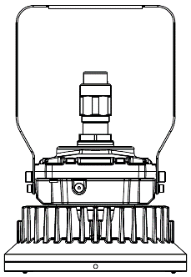**6.1.1 Two Position (Wall /Ceiling) Adjustable Trunnion Mounting Bracket**

Figure 2

Figure 1

* The mount bracket is for the use of both ceiling mount (Figure 1) and wall mount (Figure 2).
* Position the bracket holders and fix it by means of the provided M8 and M6 screws, 61.0 kgf-cm(M8), 24.5kgf-cm(M6).
* Secure the wall/ceiling mounting bracket to the structure by using two fasteners (not provided).
* The angle of lighting fixture can be adjusted.

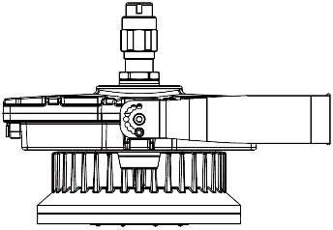

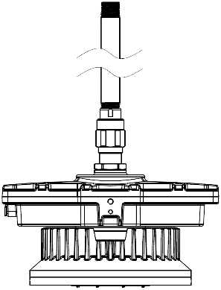

**6.1.2 Straight electrical tube mounting**

* The mounting type is for the use of straight electrical tube mounting (Figure 3).
* Straight electrical tube mounting thread is NPT 3/4”.
* Thread the tube mounting on conduit and torque until wrench-tight as requirement,1500 kgf-cm.

Figure 3

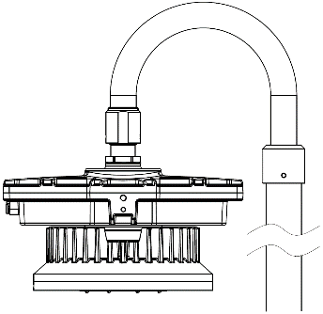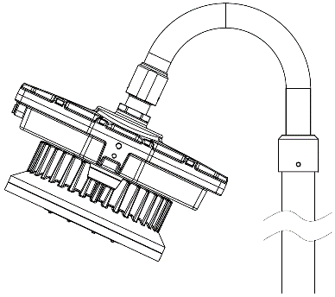**6.1.3 Bending electrical tube mounting**

* The bending electrical tube, one end secured to Cable Gland by integral M35 female threads and with a setscrew; the other end provided with 1-1/2” NPT female threads for connecting with conduit.
* Thread the tube mounting on conduit and torque until wrench-tight with 6600 kgf-cm.
* Tighten tube locking setscrew to conduit, 1.0 N-m. (Figures 4 and 5)

Figure 5

Figure 4

**6.2 Ground wire**

* The external earth ground wire installation and terminal type as show the right pictures.
* Ground wire cross-sectional area = 4 mm²，max LED current = 0.6A; @V = 100 Vac-10%.
* Both ground screw and washer material is stainless steel.
* Screw hole spec: M5.
* Torque requirement: 14.5 kgf-cm.
* Ensure wire is tied assured.

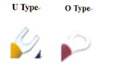

**6.3 Wake up the lighting fixtures**

* Before put the lighting into operation; please turn the knob to the left with a tool for two turns so as to turn off sleep mode.

**Attention:** Please do not turn the knob for more than two turns; otherwise the knob might be damaged.

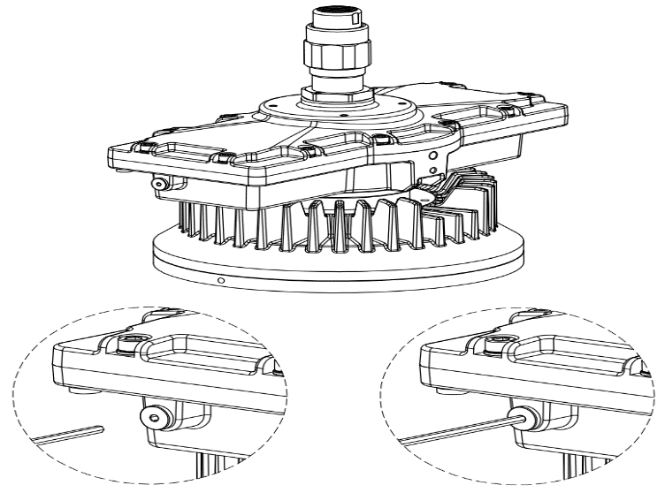

3mm Allen key

Knob

**6.4 Putting into Service**

Before putting into operating, it’s necessary to ensure that:

* the lighting is correctly installed.
* the connection has been correctly made.
* the cable has been inserted correctly.
* the voltage is correctly.
* the lighting fixture needs to be charged for 48 hours and it can provide 120 minutes illumination after fully charged.
* Continuously charge the Product for 48 hours before first time installation.
* It may result damage and/or inactive to the battery in case the Product continuously discharges over 30 days. Continuously charge the Product for 48 hours when the Product has continuously discharged for 30 days.

1. **Maintenance**

 **WARNING**

* **To avoid dangers due to energized parts, all connections and wiring must be disconnected from the power supply. Secure the connections against unauthorized activation.**
* **To avoid risk of burn to hands, let the luminaire cool down for approximate 30 minutes before touching them.**
* **Maintenance work is not permitted on flameproof enclosures. Repairs are only to be carried out by the manufacturer. Unauthorized repair shall cause the manufacturer’s liability and warranty expires.**
* **Do not attempt to service the battery. The unit uses a sealed, Li-ion battery which requires no maintenance. For replacement, contact the factory.**

**Regular Maintenance**

* Consult the relevant national regulations (e.g. IEC 60079-17) to determine the type and extent of inspections.
* Arrange the plan of regular inspection with the equipment, one time per 3-month at least, so that any defects in the equipment which may be anticipated are promptly detected.

**To check as part of the maintenance schedule as following:**

* Cracks or damages on the glass cover and/or on the enclosure.
* Condition of the connecting cables.
* Screws of the mounting bracket are tightened.

1. **Accessories and Spare Parts**

** WARNING**

**Use only original THT-EX accessories and spare parts. For accessories and spare parts, see data sheet at** [**www.tht-ex.com**](http://www.tht-ex.com)**.**

1. **Transport, Storage and Disposal**

* Transport and storage is only allowed in the original packaging, on the way pointed out on the carton box.
* Transport – Shock-free in its original carton, do not drop, and handle carefully.
* Store – Store in a dry place in its original packaging.
* Disposal – Ensure environmentally friendly disposal of all components according to the legal regulations.